SITE PROJECT – GABRIEL GALVAO DE ALBUQUERQUE MELO

Branding

Logo



Style Guide

Color Schema

https://coolors.co/396ca0-b0c9e1-785a41-163b52

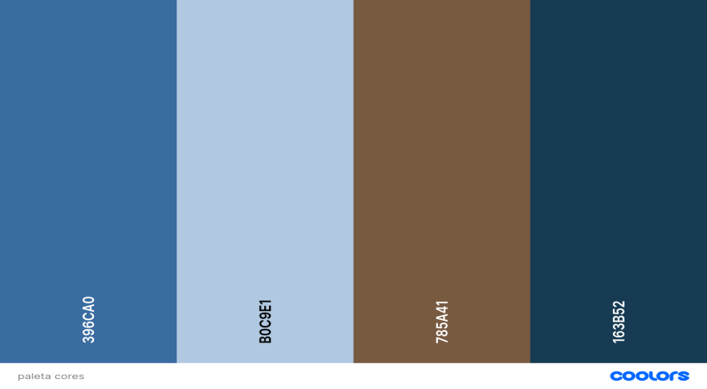

Primary-color - 396CA0

Secundary-color - B0C9E1

Accent1-color - 785A41

Accent2-color – 163B52

Typography

Heading-font –Rowdies 400 and 700

Text-font – Annie use your telescope 400